29 July 2026



Stig Enevoldsen
Chairman
EFRAG
Avenue des Arts 13-14
1210 Brussels
Belgium

By email

Dear Mr Enevoldsen

IAS 23 BORROWING COSTS

Thank you for the opportunity to comment on EFRAG’s draft response to the Exposure Draft of proposed amendments to International Accounting Standard (IAS) 23 Borrowing Costs, published for comment by the International Accounting Standards Board on 25 May 2006.

We oppose removal of the option to recognise borrowing costs immediately as an expense. We therefore are support the line taken in the main body of EFRAG’s draft response, and do not support the alternative that ‘on balance [EFRAG] support[s] the proposal in the ED’. Similarly, in relation to the response to question 1, we agree that EFRAG should oppose the proposal.

Our detailed reasoning is set out in our response to the IASB (attached).

Yours sincerely

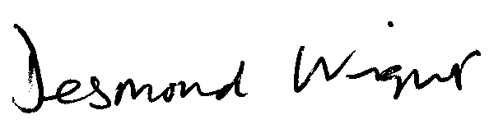

Desmond Wright
Senior Manager, Corporate Reporting
Direct line: 020 7920 8527 Fax: 020 7638 6009
Email: tdwright@icaew.co.uk




