


12 December 2006

Mr Stig Enevoldsen
Chairman
EFRAG
Avenue des Arts 13-14
1000 BRUXELLES

commentletter@efrag.org

Dear Mr. Enevoldsen

DRAFT ENDORSEMENT ADVICE ON IFRS 8 OPERATING SEGMENTS

The Institute of Chartered Accountants in England and Wales is content with EFRAG’s draft letter to the Acting Director General for the Internal Market recommending adoption of International Financial Reporting Standard (IFRS) 8 Operating Segments as published by the International Accounting Standards Board on 30 November 2006.

Yours sincerely

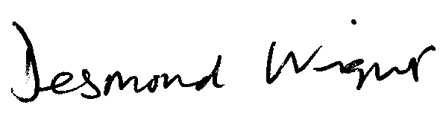
Desmond Wright
Senior Manager, Corporate Reporting
Direct line: 020 7920 8527 Fax: 020 7638 6009
Email: tdwright@icaew.co.uk

