31 July 2026



Mr Stig Enevoldsen
Chairman
EFRAG
Avenue des Arts 13-14
1210 Brussels
Belgium

By email: Commentletter@efrag.org

Dear Mr Enevoldsen

FINANCIAL INSTRUMENTS PUTTABLE AT FAIR VALUE AND OBLIGATIONS ARISING ON LIQUIDATION

Thank you for the opportunity to comment on EFRAG’s draft response to the Exposure Draft: Amendments to IAS 32 Financial Instruments: Presentation and IAS 1 Presentation of Financial Statements: Financial Instruments Puttable at Fair Value and Obligations Arising on Liquidation, published for comment by the International Accounting Standards Board on 22 June.

We are still in the process of finalising our detailed views on the Exposure Draft, but we are generally content with EFRAG’s draft letter. We do not support the amendments proposed by the IASB, because they lack a sound underlying principle and apply only to a very small set of entities.

Yours sincerely

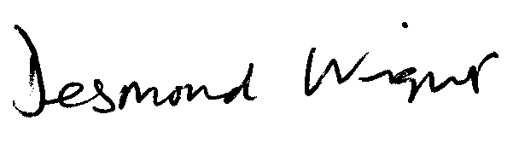

Desmond Wright
Senior Manager, Corporate Reporting
Direct line: 020 7920 8527 Fax: 020 7638 6009
Email: tdwright@icaew.co.uk




