Association of European Cooperative and Mutual Insurers  Association des Assureurs Coopératifs et Mutualistes Européens  Europaïscher Genossenschaftlicher und Wechselseitiger Versicherungsverband  An association of ICMIF and affiliated to the ICA | 

Mr Paul Ebling
European Financial Reporting Advisory Group
13-14 Avenue des Arts
1210 Brussels

Brussels, 23 November 2007

Dear Mr Ebling,

On behalf of ACME which has observer status within EFRAG and is represented at their insurance working group, we support the views expressed by EFRAG in their official comments on IASB Discussion Paper Preliminary Views on Insurance Contracts.

Yours sincerely,
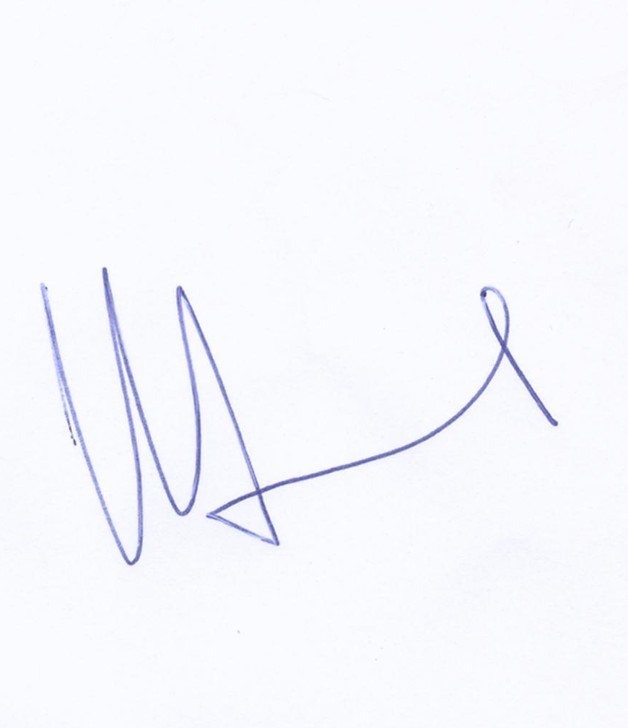

Rolf Soedjak
ACME Chair

