29 July 2026



Mr Goran Tidstrom
Supervisory Board Chairman
EFRAG
Avenue des Arts 13-14
1210 Brussels
Belgium

By email

Dear Mr Tidstrom

IFRIC DRAFT DUE PROCESS HANDBOOK

Thank you for the opportunity to comment on EFRAG’s draft response to the consultation on the Draft Handbook Due Process of the International Financial Reporting Interpretations Committee.

We are generally supportive EFRAG’s draft response, although overall EFRAG is more critical of the Draft Manual than we are. We are broadly content with the process for selecting IFRIC members, the scope of the work the IFRIC undertakes and the voting requirements for achieving a consensus. EFRAG’s suggestions - for example, for more achieving more formality in selecting and appointing Agenda Committee members and in recording and considering issues submitted for determination by IFRIC - are more than we would press for, but we are content for EFRAG to do so.

We do not have major concerns about the rejection process, although we accept that there are weaknesses that could be addressed . However, we do strongly believe that the voting requirement to reject an item from the IFRIC agenda should be the same as the requirement to pass an interpretation (ie, no more than two members voting to the contrary). We urge EFRAG to make this point in its own response. We have no objection to EFRAG seeking other process changes.

We agree that rejection notices are important, given the potential for improving consistency in application of IFRS. However, we are not necessarily convinced that, for example, there is a major problem in IFRIC declining to take an issue on to its agenda because the standard is ‘clear’. A robust framework for issuing rejection notes is important, and we are considering how to frame our own response to this issue.



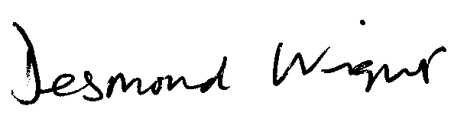
Yours sincerely

Desmond Wright
Senior Manager, Corporate Reporting
Direct line: 020 7920 8527 Fax: 020 7638 6009
Email: tdwright@icaew.co.uk

