 Conseil National de la Comptabilité
3, Boulevard Diderot  75572 PARIS CEDEX 12 |  | Paris, the 18 october 2007
Phone | 33 1 53 44 52 01
Fax | 33 1 53 18 99 43/33 1 53 44 52 33 | Stig ENEVOLDSEN
Internet | http://www.cnc.minefi.gouv.fr | Chairman EFRAG
Mel | jean-francois.lepetit@cnc.finances.gouv.fr
Chairman |  | Avenue des Arts 13-14
JFL |  | 1210 Bruxelles
n° |  | BELGIQUE
Re: ED IFRS for SMEs

Dear Stig,

Please find enclosed the comments of the Conseil national de la comptabilité (CNC) on the Exposure Draft IFRS for Small and Medium-sized Entities (ED) sent to Paul Pacter. This letter is submitted in CNC’s capacity of contributing to the IASB’s due process. In the second and third parts to this letter, we provide detailed comments and proposals in response to the invitation for comments. Our comments and proposals are derived from our key observations.

If you would like further clarification of the points raised in this letter, I would be happy to discuss these further with you.

Yours sincerely.
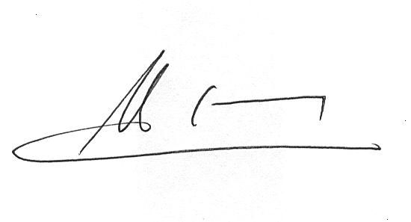
Jean-François Lepetit
Chairman of CNC

P.J. Réponse du CNC à l’exposé-sondage IFRS pour les PME.

