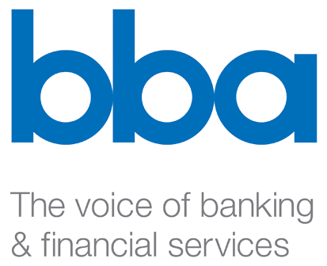

Stig Enevoldsen
EFRAG, Chairman
13-14 Avenue des Arts
B-1210 Brussels
commentletter@efrag.org
31st August 2007

Dear Stig

RE: EFRAG Response to IASB SME Exposure Draft

The British Bankers’ Association welcomes EFRAG’s decision to prepare a response to the IASB’s Exposure Draft IFRS for Small and Medium Sized Entities. We share the view that this is an important standard and provide our views to assist in the preparation of the EFRAG response.

The BBA is the leading UK banking and financial services trade association and acts on behalf of its members on domestic and international issues. Our 219 members are from 60 different countries and collectively provide the full range of banking and financial services. They operate some 130 million personal accounts, contribute £35bn to the economy, and together make up the world’s largest international banking centre.

The benefits of a global set of principles-based financial reporting standards lead our members to be firm supporters of the concept of international financial reporting standards for listed companies. We concur that it is logical for the IASB to develop a single set of principles-based accounting standards suitable for the use of companies which do not have public accountability or the technical sophistication to implement full IFRS. Such standards have the potential to realize the same benefits of increased understandability and comparability of smaller firms’ financial reports as full IFRS has for listed entities. The proposed EFRAG response rightly identifies that to be effective, however, the standard must be a stand alone document, incorporating the conceptual basis of full IFRS, but containing simplifications which allow its application by less sophisticated entities and understanding by the users of their financial statements. The Exposure Draft makes good progress towards this goal but requires amendment before it can be considered finalized.

We remain unclear as to the entities at which the IASB is targeting this standard; the label certainly contributes to this confusion. In its current form, it is clearly unsuitable for the majority of small entities, at least as defined in the European Union (i.e. an entity with less than 50 employees and with an annual turnover or balance sheet equal to or no greater than €10 million). It is perhaps most suitable for those middle tier entities which do not have public accountability but which are more complex than small entities. We point as an example to the European Union’s definition of medium-sized i.e. an entity with less than 250 employees and an annual turnover equal to or less than €50 million or an annual balance sheet equal to or less than €43 million.

Although the Exposure Draft contains some simplifications to full IFRS’s recognition and measurement requirements we agree there are still simplifications which need to be made before the standard can be considered suitable for middle tier entities. It would be appropriate for the IASB to return to this issue and to reassess whether further changes are necessary. The approach put forward in the proposed response offers a pragmatic way forward.

The proposed standard would also benefit from a thorough redrafting. The EFRAG response is right to call for it to be reorganised into sections and subsections, with principles and guidance separated. We agree that in the interest of brevity there is no need for principles and guidance to be repeated from section to section where they are the same.

We hope that these comments are of use to you. We will be more than wiling to share our response to the Exposure Draft with you once it has been agreed by our membership.

Yours sincerely,

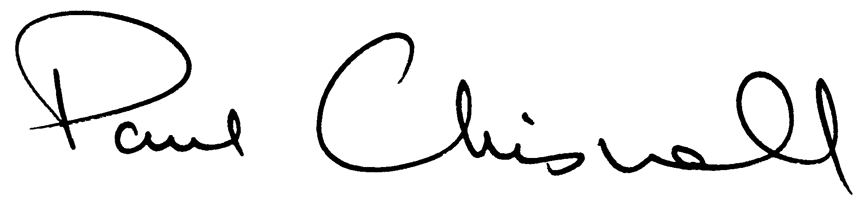

Paul Chisnall
Executive Director

