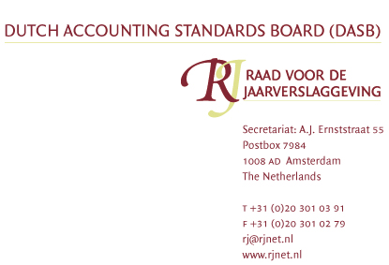

EFRAG
Attn. EFRAG Technical Expert Group
41, Avenue des Arts
B-1040 Brussels
Belgique

Our ref : AdK
Date : 9 January 2007
Re : Comment on your letter regarding the adoption of IFRIC Interpretation 11 IFRS 2 – Group and Treasury Share Transactions

Dear members of the EFRAG Technical Expert Group,

The Dutch Accounting Standard Board (DASB) appreciates the opportunity to respond to your comment letter regarding the adoption of IFRIC Interpretation 11 IFRS 2 – Group and Treasury Share Transactions.

We do not fully agree with the conclusions reached in IFRIC 11.
We support the alternative view as expressed in paragraph 22 of the appendix to your letter. We disagree with the conclusion that a subsidiary always needs to account for its plan as cash settled when the subsidiary has granted share based payments to its employees based on the shares of its parent company, regardless of any arrangement in place between the parent company and the subsidiary regarding these shares.

Nevertheless we support the adoption of this interpretation by the European Union, taking into account the importance and relevance of our objections and the need for clarity on this topic.

Yours sincerely,

Hans de Munnik RA
Chairman Dutch Accounting Standards Board

