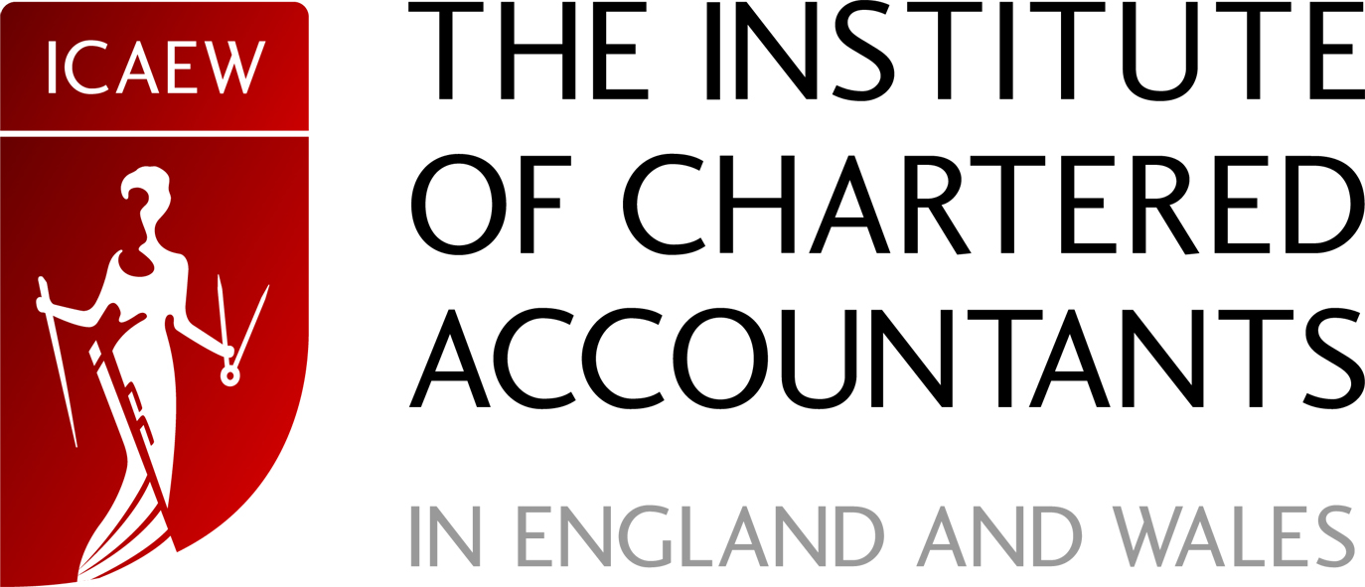

26 February 2007

Our ref: ICAEW Rep 11/07

Your ref:

Mr Stig Enevoldsen
Chairman
EFRAG
Avenue des Arts 13-14
1000 BRUXELLES

commentletter@efrag.org

Dear Mr. Enevoldsen

DRAFT ENDORSEMENT ADVICE ON IFRIC 12 ‘SERVICE CONCESSION ARRANGEMENTS’

The Institute of Chartered Accountants in England and Wales (‘the Institute’) supports EFRAG’s intention to recommend the adoption of International Financial Reporting Interpretations Committee 12 ‘Service Concession Arrangements’.

We have reviewed the draft letter to Jörgen Holmquist and noted the dissenting views. We question the relevance of setting out these views in such detail, given that the substance of the letter is to support endorsement. We suggest that the letter should be rebalanced to emphasise the assenting views and to leave no doubt that EFRAG recommends endorsement of IFRIC 12 despite any theoretical shortcomings.

The Institute itself supports IFRIC 12. Although we remain critical of aspects of the Interpretation, and share certain of the concerns raised in EFRAG’s draft letter, we accept the need for guidance in this area, and we believe that IFRIC 12 arrives at a practical solution that can be made to work and overall will improve the quality of financial reporting in Europe. The UK experience of a risks and rewards model is that it can be manipulated to achieve a desired result. The control model of IFRIC 12 is more robust in this regard, and we suggest that the majority of assets will fall to be treated as financial assets with very few being treated as intangible assets.
Chartered Accountants’ Hall  Box 433 Moorgate Place London EC2P 2BJ www.icaew.com | T +44 (0)20 7920 8100  F +44 (0)20 7920 0547  DX DX 877 London/City

In summary, we do not believe that the deficiencies of IFRIC 12 are significant enough to warrant non-endorsement by the EU, which would have serious implications for the future direction of European accounting.

We would be happy to provide any further information or assistance regarding this matter.

Yours sincerely

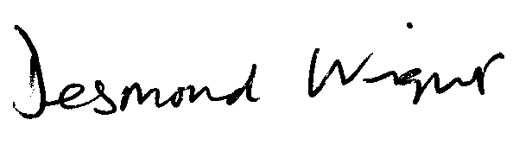

Desmond Wright
Senior Manager, Corporate Reporting
T +44 (0)20 7920 8527
F +44 (0)20 7638 6009
E desmond.wright@icaew.com

