

Mr. Stig Enevoldsen
EFRAG Chairman and CEO
Avenue des Arts/Kunstlaan 13-14
1210 Brussels
Belgium

Madrid, 26 February 2007

Dear Mr. Enevolsen:

Our company is the responsible for the service concession of Autopista Madrid Sur, CESA with total investment value at December, 2006 of Euros 669,40 million .

We know that EFRAG has analyzed the IFRIC 12 interpretation for accounting for service concession business and has posted in the website its comments favourable to the adoption by the European Union of said interpretation. In this respect we wish to underline the following comments:

- An interpretation is not the adequate way to address the problem. We believe that the minimization of the importance of the service concession industry is a major reason for the problems that this interpretation has suffered and for the inconvenience that it is creating. A new standard is necessary, not an interpretation, and the wish to solve the issue through an interpretation has delayed the IFRIC works during years and is the cause of having on the table a proposal that does not represents the true image of the business. This interpretation is in our opinion negative for the development of the infrastructure of Europe and is harmful for the European Industry.

- The question is not whether the present interpretation can be fitted into the IAS standards, but whether this interpretation is the best way to properly set the accounting obligations for this industry. It is not the narrow way, but the broad picture what should be taken into consideration. With the experience of many years in the business we know that there are better accounting rules than the complex and distorted one proposed by IFRIC, even if its conclusions may be reluctantly fitted and made compatible with IASB standards.

Therefore, in the name of our company, we underline our request for a new standard, and require from the high moral qualifications of EFRAG that in its opinion to the Accounting Regulatory Committee of the European Union it states not only its recommendation about the correct fitting of IFRIC 12 with IASB standards, but also an additional and more important recommendation advising the elaboration of a better accounting system for the service concession industry, in accordance with IASB standards, but more connected to the true image of the business and to the social convenience of the European Union objectives.

We suggest EFRAG to recommend in the meantime, and while this new standard is elaborated, IFRIC 12 to be amended in order to include into the intangible model the alternative of percentage of completion accounting.

We remain,

Sincerely Yours

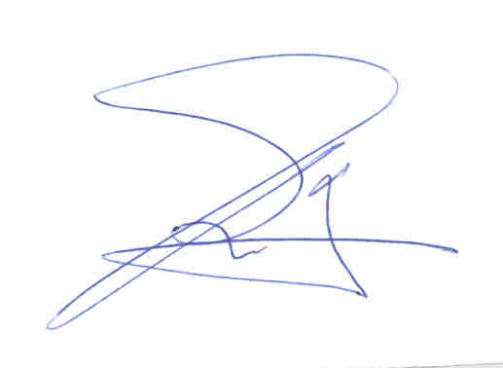

José Carlos Rivero Moya
Financial Manager

