
23 September 2010

European Financial Reporting Advisory Group
35 Square de Meeûs
B-1000 Brussels
Belgium

To: commentletters@efrag.org

Dear Sirs
Consultation on Proactive Work

I am writing on behalf of AFME (the Association for Financial Markets in Europe) to set out our response to EFRAG’s Consultation on Proactive Work (“the Consultation”), which was announced on 28 June. AFME is, as you know, the leading European trade association for firms active in investment banking and securities trading; it was established on 1 November 2009 as a result of the merger of LIBA (the London Investment Banking Association) and the European Branch of SIFMA (the US-based Securities Industry and Financial Markets Association), and thus represents the shared interests of a broad range of participants in the wholesale financial markets. We welcome the opportunity to respond to this Consultation.

Our members include a high proportion of the major participants in the global financial markets, most of whom have operations in all significant EU markets, as well as in the other key markets around the world: they report regularly in different places under both IFRS and US GAAP (and also, to the extent that they remain in use, under other local GAAPs). As discussed in my 3 September meeting with Françoise Flores and Pieter Dekker, the overriding concern of our members is to see continued progress towards convergence between IFRS and US GAAP, along with the full endorsement of all IFRS for use in the EU: we believe such progress to be essential if the European markets are to remain competitive in an ever more integrated world. A secondary concern is to see continued progress towards the full adoption of IFRS by those jurisdictions which do not yet adhere either to IFRS or to US GAAP.

We believe EFRAG has a critical role to play in ensuring that progress towards convergence (and, to a lesser extent, progress towards further adoption of IFRS in third countries) can continue in a way which will ensure maximum benefit to those who operate in, and to those who seek to raise capital in, the European financial markets. We therefore strongly support the key points set out in paragraph 3.3 of the Consultation, namely that EFRAG’s proactive work should:

- “(complement) the current development of IFRS”; and

- “aim to address real and important issues encountered in practice within the European environment”.

It follows, we believe, that EFRAG’s proactive work must be complementary to its primary objective of “assisting the European Commission in the endorsement of (IFRS) … by providing advice on the technical quality of IFRS”, and it is therefore essential that all proactive projects be constructed so as to reinforce, rather than to detract from, that objective.

Our responses to the questions set out on page 4 of the Consultation are set out below, and should be read in the context of the above general comments.

Q1. Prior to this consultation were you aware of EFRAG’s Proactive Accounting in Europe (PAAinE) publications? Did you find them useful and why or why not? In what ways do you think they could have been improved? Do you think they had a sufficient focus on European issues?

A. We see the PAAinE publications as providing useful input to IASB work, particularly in those areas, such as Pension Accounting, where European operational practice may give rise to specific technical issues.

Q2. Based on the description above (under ‘How we influence the IASB’), at what point in the standard-setting process should EFRAG focus its proactive work? Also are there specific aspects of financial reporting where we should concentrate our activities?

A. We fully support the view (set out in paragraph 3.1 of the Consultation) that EFRAG’s proactive work should wherever possible be “early-stage”: issues should be identified and proposals developed “well ahead of them being added to IASB’s active work programme”.

Q3. Table 2 ‘Proposed Proactive Projects’ below identifies projects where EFRAG considers it may be useful to undertake proactive work. Can you rank the projects from most to least important based on EFRAG’s strategic aims:
Aim 1: Influence the development of global financial reporting standards;
Aim 2: Engage with European constituents to ensure we understand their issues and how financial reporting affects them;
Aim 3: Provide thought leadership in developing the principles and practices that underpin financial reporting; and
Aim 4: Promote solutions that improve the quality of information, are practical, and enhance transparency and accountability.

A. In general, we see the projects associated with the IASB’s post-implementation reviews as being the most important based on EFRAG’s strategic aims (particularly Aim 1 and Aim 2); of the three such review topics identified in Table 2, we would identify IFRS 3 “Business Combinations” as being the most significant for our members.

Q4. If there are other projects you consider more important include them in your ranking and provide a short description of them along with your reasons as to why you believe they are important for EFRAG to consider.

A. We have not identified any such projects.

*****************************************************************

I hope the above comments are helpful. We would of course be pleased to discuss any points which you may find unclear, or where you believe AFME members might be able to assist in other ways.

Yours faithfully
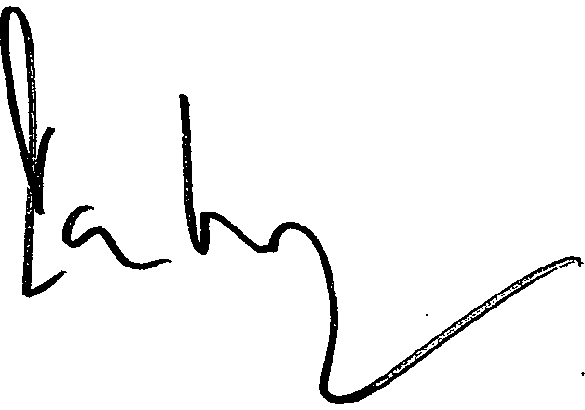
Ian Harrison
Managing Director
Direct phone: 020 7743 9349
Email: ian.harrison@afme.eu

