

Stig Enevoldsen
Chairman
EFRAG
35 Square de Meeûs
B-1000 Brussels

commentletter@efrag.org

9th November 2009

Dear Stig,

Draft endorsement advice and effects study report on IFRS 9 Financial Instruments

This is the British Bankers’ Association’s (‘BBA’) response to the invitation to comment on the above endorsement advice. We fully support the conclusion of the technical assessment and agree that IFRS 9 should be endorsed for use within the EU as soon as is practicable.

We welcome the decision taken by the Supervisory Board to assess whether IFRS 9 meets the technical criteria for endorsement on a fast track basis and the opportunity to provide our views on the conclusions reached in the course of these deliberations. We set out our response to the questions posed in the invitation to comment in the attached annex. Before proceeding to these, however, we wish to set out the broader context in which we believe this endorsement decision should be viewed and why we believe that it is imperative for the European Union to endorse the new standard.

Despite the expedited timetable, the IASB has fulfilled its due process requirements. It has undertaken a comprehensive outreach programme and has responded to concerns raised as a result of the consultation process in a number of important areas. There is no reason in our view for endorsement to be delayed due to concerns over inadequate due process.

We note that the dissenting opinion in Appendix 4 of the invitation to comment expresses dissatisfaction with the manner in which the project is being undertaken; contending that this will give rise to material consequential amendments being made to IFRS 9 in the near future. Whilst our members would have favoured the review of IAS 39 to have been undertaken in the round, we accept that the unprecedented circumstances of the financial turmoil, coupled with intense political pressure for piecemeal changes, left the IASB little choice but to proceed in the manner in which it did. On the whole, we believe that the decision to assess IAS 39 in its entirety, even over an extended time period, was preferable to a number of ill-considered, short term amendments.

The European Commission was one of the 244 respondents to the Exposure Draft following consultation with a broad range of European stakeholders. We believe that the IASB has responded satisfactorily to each of the concerns – many of which we shared - raised in the Commission’s letter of 15 September 2009 and that IFRS 9 is now a higher quality standard as a result. Concerns about the impairment of AFS debt securities have been resolved as under the new classification model debt securities previously classified as AFS will be reclassified to either amortised cost or FVTPL. This model also has the benefit of avoiding the need for a complex, rule driven approach to impairment as prevails under US GAAP. We consider that the line between the two new classification categories is drawn broadly in the right place and that IFRS 9 will not necessarily lead to an increase in the number of instruments held at fair value. As befits a principles-based standard, the key driver of classification will be the business model of the entity. This is consistent with the mixed-measurement model strongly supported by the UK banking industry. We are pleased that the IASB has reversed its initial decision to prohibit reclassifications between the amortised cost and fair value categories. To us, reclassification always fitted intellectually within a classification structure based on the use an entity puts an instrument to under its business model; if this changes it follows that the classification should change also.

Furthermore, we believe that the convergence of standards for the measurement and classification of financial instruments should be on the basis of the mixed-measurement model contained in IFRS 9 rather than the full fair value model being development by the FASB. We believe that this is the position of the European Commission also. The Commission should therefore use endorsement of IFRS 9 to signal that this is the basis on which it wants to see future convergence undertaken.

In conclusion, we would argue that, although mandatory adoption of the final standard will not take place until 2013, financial institutions based in Europe should not be denied the option to early adopt if they so wish. The management of each firm is in the best position to decide whether its circumstances warrant early adoption and should be granted this flexibility. As is noted in Appendix 3 of the invitation to comment, the year-one costs of applying the new standards are likely to be significant but we believe that the transition arrangements are sufficient.

For the reasons outlined above, we therefore urge the European Union to adopt IFRS 9 as soon as is practicable. For the record, our answers to the specific questions posed in the invitation to comment are included in the attached annex. We support each of the conclusions reached by the Technical Expert Group.

Yours sincerely

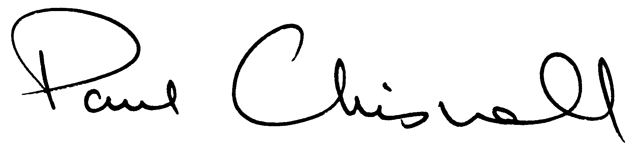

Paul Chisnall
Annex 1 – BBA response Invitation to Comment on EFRAG’s IFRS 9 endorsement advice
- Please provide the following details about yourself:
- Your name or, if you are responding on behalf of an organisation or company, its name:

British Bankers’ Association
- Are you/your organisation or company a:

Preparer User Other (please specify)

Trade association
- Please provide a short description of your activity/ the general activity of your organisation or company:

Representation of the banking and financial services industry in the UK
- Country where you/your organisation or company is located:

UK
- Contact details including e-mail address:

Paul Chisnall
Executive Director
British Bankers’ Association
Pinners Hall
105-108 Old Broad Street
London
EC2N 1EX
UK

Paul.chisnall@bba.org.uk
- EFRAG’s initial assessment of IFRS 9 is that it meets the technical criteria for endorsement. In other words, it is not contrary to the true and fair principle and it meets the criteria of understandability, relevance, reliability and comparability. EFRAG’s reasoning is set out in Appendix 2.
- Do you agree with this assessment?

Yes No

If you do not, please explain why you do not agree and what you believe the implications of this should be for EFRAG’s endorsement advice.

- Are there any issues that are not mentioned in Appendix 2 that you believe EFRAG should take into account in its technical evaluation of the amendment? If there are, what are those issues and why do you believe they are relevant to the evaluation?

We do not believe it is necessary for EFRAG to consider any further issues in evaluating the amendment.
- EFRAG is also assessing the costs that will arise for preparers and for users on implementation of IFRS 9 in the EU, both on initial adoption and in subsequent years. Some initial work has been carried out, and the responses to this Invitation to Comment will be used to complete that assessment.
The results of the initial assessment are set out in paragraphs 8, 11, 15 and 23 of Appendix 3. To summarise, EFRAG’s initial assessment of IFRS 9 is that:
- For prepares, there may be significant year one costs arising from initial adoption of the Standard and not significant costs from transition and additional disclosure requirements; and moderate ongoing incremental costs.
- For users, application of IFRS 9 is likely to involve significant additional costs in year-one and, for some users, moderate ongoing incremental costs.

Do you agree with this assessment?

Yes No

If you do not, please explain why you do not and (if possible) explain broadly what you believe the costs involved will be?

- EFRAG’s initial assessment is that IFRS 9 will reduce complexity in the classification and measurement aspect of reporting financial instruments (see Appendix 3, paragraphs 17 and 19) and that the benefits to be derived from that are likely to exceed the costs involved (see Appendix 3, paragraph 24 and 25).

Do you agree with this assessment?

Yes No

If you do not, please explain why you do not and what you think the implications should be for EFRAG’s endorsement advice?

- EFRAG is not aware of any other factors that should be taken into account in reaching a decision as to what endorsement advice it should give the European Commission on the amendment.

Do you agree that there are no other factors?

Yes No

If you do not, please explain why you do not and what you think the implications should be for EFRAG’s endorsement advice?

