Goran Tidstrom
European Financial Reporting Advisory Group
13/14 Avenue des Arts
B-1210 Brussels
Belgium

22 September 2008

Dear Goran

Strengthening the European contribution to international accounting standard setting

The Association of Chartered Certified Accountants (ACCA) is pleased to have this opportunity to respond to the proposals from the European Financial Reporting Advisory Group (EFRAG) in this regard,. The consultation paper was considered by ACCA’s Financial Reporting Committee and I am writing to give you their views.

ACCA is the largest and fastest-growing global professional accountancy body with 325,000 students and 122,000 members in 170 countries. We aim to offer first-choice qualifications to people of application, ability and ambition around the world who seek a rewarding career in accounting, finance and management. ACCA works to achieve and promote the highest professional, ethical and governance standards and advance the public interest.

Overall comments

ACCA supports IFRS as the global set of accounting standards and so EFRAG’s work promoting them in Europe. EFRAG should continue to pursue a constructive role in the process by providing high quality, respected reactions to IASB’s consultations and via the endorsement mechanism. EFRAG should ensure that it avoids unnecessary duplication with work done elsewhere by national standards setters (NSS) and IASB for example.

One of the areas where EFRAG should be doing more is in proactive projects on issues where the IASB has not yet considered the issue or not yet reached a position. The recent discussion papers on pensions reporting and on the debt/equity distinction represent valuable and visible progress in meeting this objective. We agree with the priority that is attached to this objective in these proposals for change.

EFRAG should also continue to promote an active and well-informed debate on the proposals of the IASB. We note EFRAG’s significant achievements in this area as a result of its draft comment letters in particular. This is an important role for EFRAG and in reacting to the proposals we are surprised not to find this referred to in section 2 of the paper. In our view Section 1 is wrong to identify the aim as for Europe “to speak with one voice” in relation to IFRS. This is unrealistic because different interest groups within Europe will have different perspectives on some issues. It would furthermore be undesirable if the range of views and experiences within Europe were not communicated fully to the IASB. EFRAG should be encouraging more and better informed input to IASB from these various European interest groups.

We are pleased to note the increased resources that should be provided to EFRAG via national funding mechanisms and the European Commission which is fully justified by the tasks assigned to it.

Proposals on EFRAG governance

We agree with the proposals for a General Assembly.

In terms of the Supervisory Board (SB) we note the relatively small representation given to SMEs. Financial reporting issues covered by EFRAG are in our view going increasingly to come to affect (directly or indirectly) private companies, the vast bulk of which are small or medium-sized. In 2009 IASB is likely to issue a standard for private companies (which will continue to be maintained periodically thereafter) which though perhaps not endorsed under the IAS Regulation is likely to be very influential nevertheless on private company reporting in many European countries. While we support the continued allocation of a SB member from an SME background we think that in filling the places allotted to other interest groups (preparers, users and auditors) the Nominating Committee should have the significance of private companies in mind and not allow these members to be entirely dominated by the interests of listed companies.

We very much support the idea of closer co-ordination of the work of EFRAG and the NSS to achieve the maximum effect and so are pleased to note the development of the Planning and Resources Committee (PRC) to oversee this. We see that the PRC will help to avoid the duplication noted above with the work of NSS.

We would note however some aspects of the proposals that might be addressed.
- It does not seem ideal for the PRC to include SB members given that the SB is meant to have an oversight function over the whole of EFRAG including the Technical Expert Group (TEG) and PRC. It would seem a better governance model to keep the two very separate and replace the SB members on PRC with external members or members of the TEG.
- No mention is made of the extent to which NSS and EFRAG will be pooling resources of manpower or expertise, which PRC as its main role will be prioritising and allocating to different projects.

If there are any matters arising from the above please get back to me.

Yours sincerely

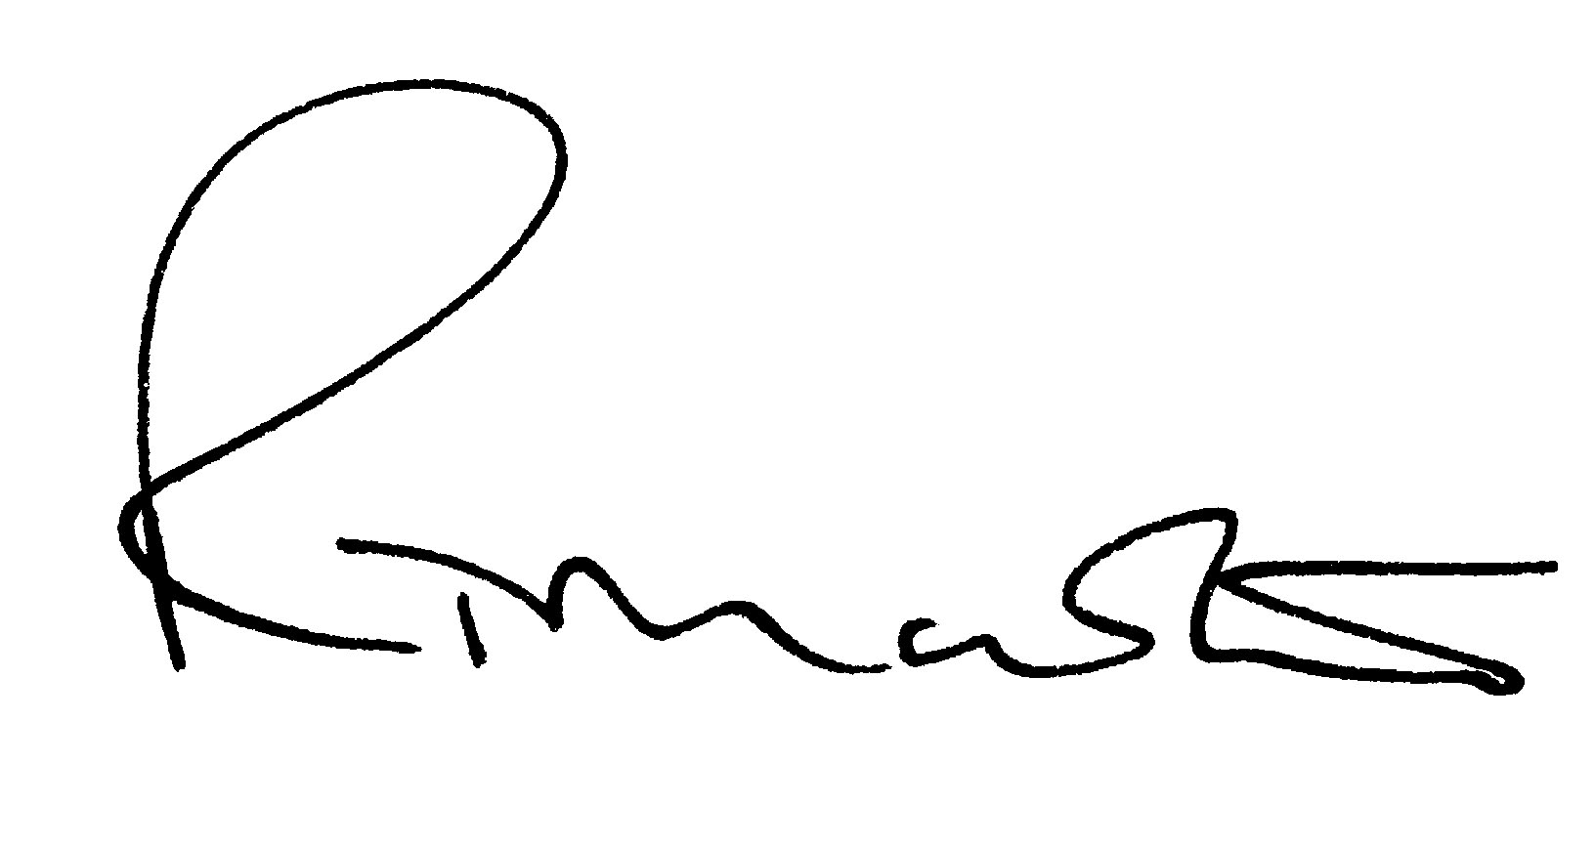

Richard Martin
Head of Financial Reporting

