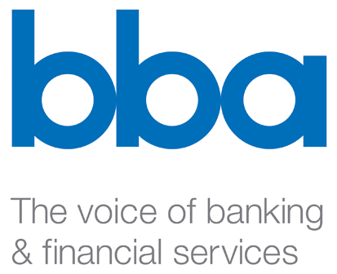

Göran Tidstrom
Chairman, EFRAG Supervisory board
13-14 Avenue des Arts
B-1210 Brussels
info@efrag.org

19 September 2008

Dear Göran,

Strengthening the European Contribution to the International Standard Setting Process

This is the British Bankers’ Association’s response to the above public consultation. The BBA is the leading association for the UK banking and financial services sector, speaking for 223 banking members from 60 countries on the full range of UK or international banking issues and engaging with 37 associated professional firms. Collectively providing the full range of services, our member banks make up the world's largest international banking centre, operating some 150 million accounts and contributing £50 billion annually to the UK economy. We welcome the opportunity to comment.

We are firm supporters of EFRAG and welcome the valuable contribution it has made to the standard setting process. In a short time EFRAG has become a respected contributor to the development of International Financial Reporting Standards and a source of high quality technical advice for the European Union. At the same time, we have become increasingly concerned that the International Accounting Standards Board has failed to take adequate account of the views of its European constituents. While we hope that the ongoing enhancements to the IASB’s due process and governance arrangements will improve matters, we fully agree that there is a need for Europe to be more pro-active in its engagement.

We agree that EFRAG should pursue the objectives and activities listed in section 2 of the consultation paper. The main functions of EFRAG should be:

- Proactive work providing input to the IASB on topics on its work programme and related priorities;
- Commenting on IASB/IFRIC consultation papers;
- Impact assessments and effect studies on IAS standards and IFRIC interpretations at the request of the EC; and
- Endorsement advice to the EC.

Of the above, we attach the highest priority to the first and the second. We agree with the view expressed in the paper that it should be possible to reduce work on impact studies if, as expected, the IASB devotes more time to conducting its own, reliable, studies.

The consultation paper rightly notes that if more resources are to be invested in EFRAG the current governance and accountability structures must evolve also. The paper sets out an extensive proposal for how these enhancements could be made. We broadly agree with the modal proposed and cannot identify any weaknesses in its transparency or accountability arrangements. We would be happy, however, to nominate suitable candidates for the proposed Consultative Group.

We accept that expanding EFRAG’s activities will necessitate an increase in the current level of funding and do not disagree with the budgets proposed for 2009 and 2010. As IFRS is of fundamental importance to the health of European capital markets, we believe it is entirely appropriate for the European Commission to make a contribution to the funding of EFRAG.

We do believe, however, that the large increase in funding makes it important that the Supervisory Board and the General Assembly monitor the effectiveness of the work undertaken by EFRAG, perhaps by making a comparison to the work undertaken by similar bodies in the same period. We also suggest that a review of the new structure should be conducted after two years to consider its operation and how it might be enhanced further.

In closing, we welcome the proposals and urge their adoption. We look forward to participating in future projects.

Yours sincerely,

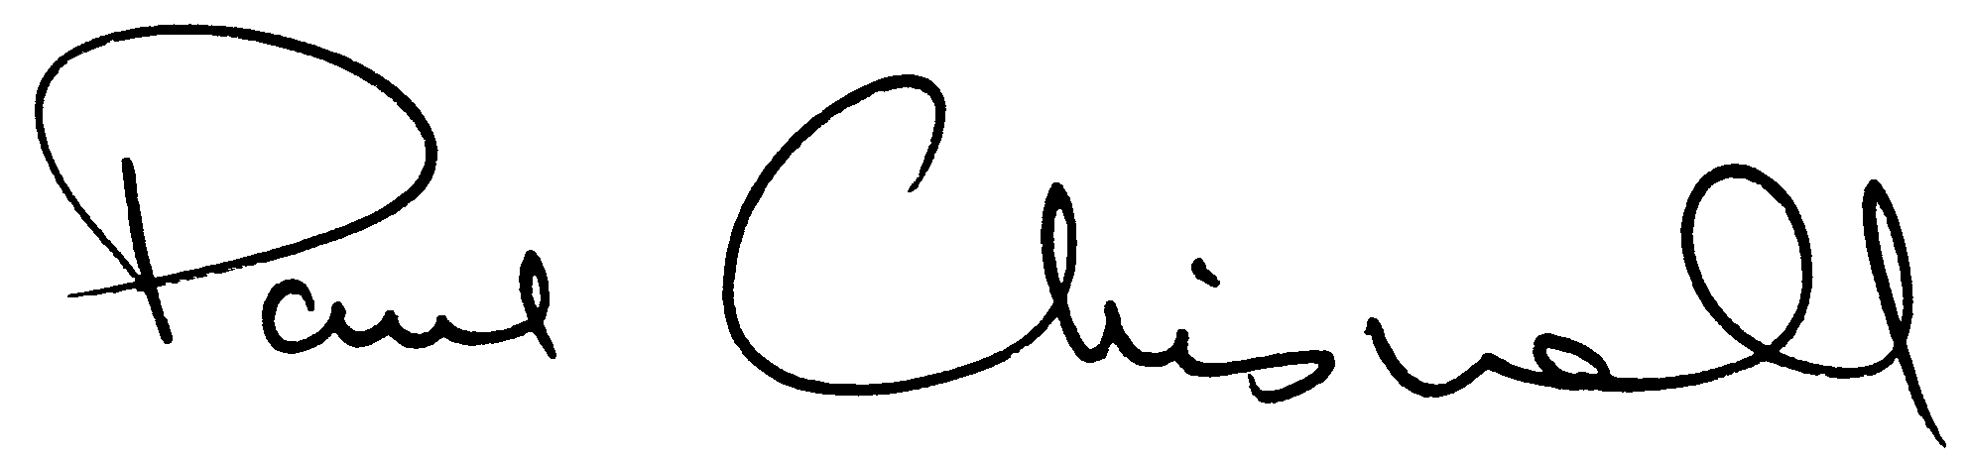

Paul Chisnall
Executive Director
Direct Line: 020 7216 8865
E-mail: paul.chisnall@bba.org.uk

