LIBA | London Investment Banking Association  6 Frederick’s Place, London, EC2R 8BT  Tel: 020-7796 3606 Fax: 020-7796 4345  Direct: 020-7367 5507 E-mail: ian.harrison@liba.org.uk

19 September 2008

Göran Tidström
Chairman of the Supervisory Board
EFRAG
Avenue des Arts 13-14
B-1210 Brussels

By e-mail to: info@efrag.org

Dear Mr Tidström

Enhancement of EFRAG – Proposals for Public Consultation

I am writing on behalf on the London Investment Banking Association (LIBA) to comment on EFRAG’s 23 July Proposals for Public Consultation: Strengthening the European Contribution to the International Standard-Setting Process. LIBA is, as you know, the principal UK trade association for investment banks and securities houses; a list of our members is attached.

The LIBA Accounting Committee has strongly supported the work of the EFRAG since its establishment in 2001, while also following closely the European debate over the appropriate governance structure and operating procedures for the IASCF and the IASB.

We recognise the concerns that have arisen, particularly in recent years, in the European Parliament and elsewhere, over aspects of the public accountability of the IASCF/IASB and over the transparency of their decision-making processes. We have for some time believed (and have stated informally to both EFRAG and the European Commission) that an essential step towards allaying these concerns is to provide an effective way for European stakeholders to feed their views into the IASB at an early stage of their deliberations.

We are therefore pleased to see that EFRAG identifies the need “to place more emphasis on developing its own research and discussion papers at an early stage of the IASB’s consideration of the topics concerned” (emphasis added) as a key objective of the proposed enhancement.

We endorse, in particular, the proposal to establish a Planning and Resource Committee (PRC) which will include “four senior NSS representatives”, with the key task of ensuring “that (EFRAG’s) long-term proactive agenda reflects the most important accounting issues seen from a European view”; we believe the creation of the PRC should significantly improve the extent to which key European concerns are flagged up to the IASB at an early stage in their deliberative processes.

EU stakeholders must, however, accept that this new structure will not (and should not) provide any guarantee that European views will necessarily prevail in every case: while EU-listed companies, as measured by market capitalisation, currently form a very substantial proportion of all IFRS users, the IASB cannot allow its independence to be compromised, and must therefore be free to set the standards which it decides are most appropriate for all its stakeholders. Any (actual or perceived) failure to adhere to this principle would inevitably risk compromising the long-term goal of continued convergence towards a single global set of high-class accounting standards: achievement of this goal will, we believe, bring very substantial benefits to the EU economy.

In summary, we see the proposed changes as sensible and constructive. We believe they should lead to greater confidence in EFRAG’s key role of ensuring that European views and concerns can be fully taken into account in the IASB standard-setting process. We believe, moreover, that the proposed “EFRAG Plus” is both a more practical and a more constructive approach than the possible establishment of a separate European Standard-Setting body, as has on occasion been suggested by some constituents.

********************

I hope these comments are helpful. We would of course be pleased to expand on any points which you may find unclear, or where you would like further details of our views.

Yours sincerely
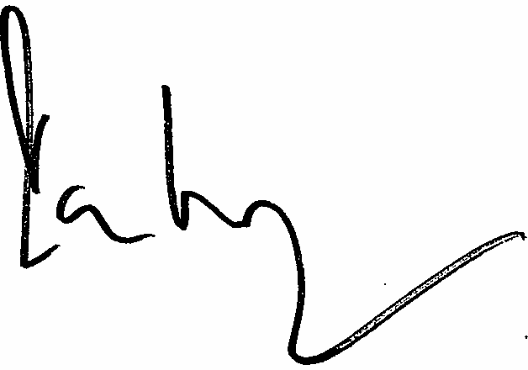
Ian Harrison
Director

LONDON INVESTMENT BANKING ASSOCIATION

LIST OF MEMBERS

ABN AMRO Bank
Altium Capital Limited
Ambrian Partners Limited
Arbuthnot Latham & Co., Limited
Arbuthnot Securities Limited
Arden Partners plc
Banc of America Securities Limited
Barclays Capital
Bear, Stearns International Limited
BlueOar Securities Plc
BNP Paribas
Brewin Dolphin Securities
Calyon
Cantor Fitzgerald Europe
Cenkos Securities Limited
CIBC World Markets
Citigroup Inc.
Close Brothers Corporate Finance Ltd
Collins Stewart Europe Limited
Credit Suisse Securities (Europe) Ltd
Daiwa Securities SMBC Europe Limited
Dawnay, Day International Ltd
Deutsche Bank AG London
Dresdner Kleinwort
Evolution Securities Limited
Fox-Pitt Kelton Limited
Goldman Sachs International
Greenhill & Co. International LLP
HBOS Treasury Services plc
HSBC Bank plc
ING Bank NV London Branch
Instinet Europe Ltd
Investec plc
Jefferies International Limited
JP Morgan Cazenove Ltd
JP Morgan Securities Ltd
KBC Peel Hunt Ltd
Kaupthing Singer & Friedlander
Landsbanki Securities (UK) Limited
Lazard & Co., Limited
Lehman Brothers
Libertas Capital Group plc
Merrill Lynch Europe plc
Mizuho International plc
Morgan Stanley & Co. International plc
NCB Stockbrokers Limited
Noble & Company Limited
Nomura Code Securities Limited
Nomura International plc
N M Rothschild & Sons Limited
Numis Securities Limited
Oriel Securities Limited
Panmure Gordon & Co
Piper Jaffray Ltd
Royal Bank of Canada Europe Limited
Sanford C. Bernstein Limited
Société Générale
3i Group plc
UBS AG London
Winterflood Securities Limited

19 September 2008

