 Conseil National de la Comptabilité
3, Boulevard Diderot  75572 PARIS CEDEX 12 |  | Paris, 1st October 2007
Téléphone | 01 53 44 52 01
Télécopie | 01 53 18 99 43/01 53 44 52 33
Internet | http://www.cnc.minefi.gouv.fr | Mr. Robert P. Garnett
Mel | jean-francois.lepetit@cnc.finances.gouv.fr | IFRIC
Le Président |  | 30 Cannon Street
JFL/MPC |  | LONDON EC4M 6XH
n° 587 |  | United Kingdom
Re : IFRIC Draft Interpretation D 22 – Hedges of a Net Investment in a Foreign Operation
Dear Mr. Garnett,
The Conseil National de la Comptabilité (CNC) examined the IFRIC Draft Interpretation D 22 - Hedges of a Net Investment in a Foreign Operation.
We support the consensus of the Draft Interpretation.
- Regarding the nature of the hedged risk for which a hedging relationship may be designated, we support the fact that hedge accounting may only be applied to the foreign exchange differences arising between the functional currency of the foreign operation and the functional currency of any intermediate or ultimate parent entity. We agree with the paragraph BC12 c, which mentions that an exchange rate risk arises only from an exposure between two or more functional currencies, not from a presentation currency.
- Regarding the hedging instrument, we also support the fact that it may be held by any entity within the group, as long as the requirements of IAS 39 are satisfied.

Nevertheless, when the hedging instrument is not in the entity hedging its net investment, we consider that difficulties in assessing effectiveness of the hedging relationship could be serious. As illustrated in Example 3B, when the functional currency of

the entity hedging its net investment,

the parent entity hedging its foreign operation and

the entity which holds the hedging instrument

are different, it is necessary to compute diverse accounting entries which affect equity and profit and loss accounts to assess the total change in value of the instrument.

In this context, the paragraph 13 which mentions that « depending on where the hedging instrument is held, the total change in value may be recorded in profit or loss, or equity, or both » should be clarified for the consensus to be more explicit.
We hope you find these comments useful and would be pleased to provide any further information you might require.

Yours sincerely,

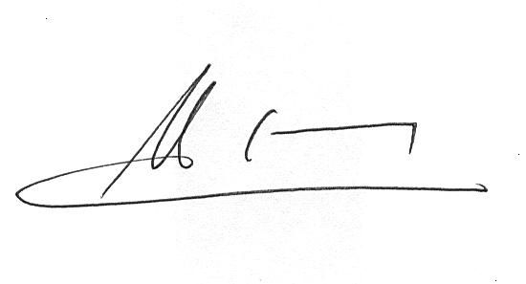

Jean-François Lepetit

