

 Conseil National de la Comptabilité
3, Boulevard Diderot  75572 PARIS CEDEX 12 |  | Paris, 7th January 2008
Téléphone | 01.53.44.52.01
Télécopie | 01 53 18 99 43 / 01 53 44 52 33
Internet | http://www.cnc.minefi.gouv.fr/
Mel | jean-francois.lepetit@cnc.finances.gouv.fr
Le Président |  | Stig Enevoldsen  Chairman  EFRAG  Avenue des Arts 13/14  1210 Bruxelles  Belgique
JFL/PhS
N°08

EFRAG COMMENT LETTER ON EXPOSURE DRAFT ED9 JOINT ARRANGEMENTS

Dear Stig,

I am writing on behalf of the CNC to give you our comments on the above-mentioned EFRAG draft comment letter.
For your information, our draft reply to the IASB exposure draft is attached .
We agree with the main conclusions of the EFRAG and in particular that:
- ED9 does not make a convincing case for eliminating the option of proportionate consolidation contained in IAS 31 and that its elimination would cause disruption in many countries where it is the general practice
- That it would be premature to eliminate this option given that the subjects of control and asset definition are currently under review in key Joint Board projects
- That ED9 would not lead to an improvement in the quality of financial reporting because the generalisation of equity accounting will lead to a transfer of key operating data from the primary financial statements to the notes.
- That ED9 will not achieve convergence because it does not allow the exemptions available under US GAAP

Joint ventures are a strategic business model for many of our constituents and in view of the above objections it is our opinion that no change should be made to IAS 31 at this stage.
We hope you find these comments useful and would be pleased to provide any further information you might require.

Yours sincerely,
With best regards
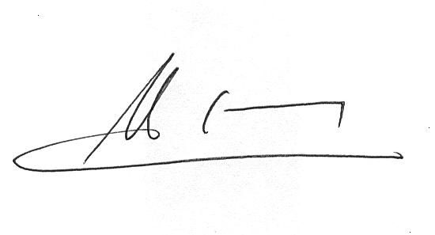
Jean-François Lepetit

