 Conseil National de la Comptabilité
3, Boulevard Diderot  75572 PARIS CEDEX 12 |  | Paris, 8th January 2008
Téléphone | 01 53 44 52 01
Télécopie | 01 53 18 99 43/01 53 44 52 33
Internet | http://www.cnc.minefi.gouv.fr | Mr. Stig Enevoldsen
Mel | jean-francois.lepetit@cnc.finances.gouv.fr | EFRAG
Le Président |  | 13-14 Avenue des Arts
JFL/MPC |  | 1210 BRUSSELS
n° 09 |  | Belgium
Re : Exposure Draft of Proposed Improvements to International Financial Reporting Standards
Dear Stig,
Please find enclosed for your information the CNC Comment Letter to the IASB on the Exposure Draft of Proposed Improvements to International Financial Reporting Standards.
The CNC answers relative to the specific questions to the constituents in the EFRAG Draft Comment Letter are the following.
IAS 16 - Issue 10: Sale of assets held for rental
EFRAG would particularly welcome your comments on the views expressed on the changes to IAS 7. Is the asymmetry described a concern?
EFRAG is also concerned about whether it is appropriate to make a change of this kind through the Annual Improvements Project. Do you have a view on this issue?
The CNC considers that the asymmetry described is a concern. The CNC disagrees with the presentation of sales cash flows in “operating activities”. As cash flows from purchasing or production of fixed assets are “investing activities”, the classification of sales cash flows in “operating activities” would create a mismatch detrimental to the understanding of the sub-totals by activity in the cash flow statement.
However, the CNC considers that the proposed amendment is in the scope of the Annual Improvements Project.
IAS 20 - Issue 19: Government loans with a below-market rate of interest
Do you agree that the IASB should be asked to include additional guidance on the issues referred to above?
Are there any other situations, concerning the requirement to impute interest on government loans, where in your view application guidance is needed?
The CNC agrees with the proposed amendment. Nevertheless, the CNC agrees that more « guidance » is required to implement the proposed amendment.
IAS 38 - Issue 28: Advertising and promotional activities
The Annual Improvements process is supposed to be used for relatively minor changes in accounting standards; more substantial changes to IFRS should be the subject of standalone amendments projects. We would welcome views as to whether this proposed amendment is a minor amendment. For example, do you believe it will change practice significantly?
As mentioned in the Comment Letter to the IASB, the CNC does not agree with the proposed amendment. This is an area where there is divergent practice and it touches on a more fundamental question relating to the distinction between an expense and an asset, which is not limited to IAS 38.
For example, the proposed guidance would require a retailer who distributes catalogues (mail order selling) to its customers to recognise an expense when it has access to those catalogues, although those catalogues arguably meet the definition of an asset until they are distributed to customers. The same could be argued for samples distributed to customers upon launch of a new product.
Therefore, we do not believe that this is a minor amendment within the scope of the annual improvements process. Instead, we believe that the issue of when it is appropriate to recognise an expense or an asset with respect to an expenditure should be the subject of a separate Exposure Draft to enable full debate of the issues.
We further note that in setting out a 'bright line' as to when an expense or asset should be recognised, this may encourage entities to structure transactions so as to fit that 'bright line' rather than accounting for transactions on the basis of their substance. Referring back to the above catalogue example, a retailer could merely structure delivery to reflect the point in time at which it wished to recognise an expense rather than when the catalogues ceased to be an asset.
In addition, we support the alternative view expressed in the Exposure Draft.
IAS 39 - Issue 30: Definition of a derivative
Do you agree with the proposal to amend IAS 39 by removing from the definition of a derivative the exclusion relating to contracts linked to non-financial variables that are specific to a party to the contract? If not, why?
As mentioned in the CNC Comment Letter to the IASB, we disagree with the proposed modification of the definition of derivatives which eliminates the reference to non-financial variables.
The CNC considers that the consequences of such a change should be assessed before proceeding with any modification of IAS 39. As a certain number of debt instruments are indexed to non-financial variables (“covenants”), this amendment is likely to have important consequences on the designation and measurement of these contracts.
The CNC considers that this proposed amendment should not be treated in an Exposure Draft on improvements, but should be dealt with as an amendment of IAS 39 in its own right.
IAS 40 - Issue 35: Property under construction or development for future use as investment property
EFRAG would particularly welcome your comments on the views expressed on the possibility to revalue assets under construction under IAS 16.
Do you believe that such a possible change of substance should be part of the annual improvement project?
The CNC considers that the amendment raises additional questions of assets under construction falling into the scope of IAS 16. In its response to IASB , the CNC requests that the Board clarifies which method under IAS 16 should be applied in measuring such assets (cost or revalued amount).
We hope you find these comments useful and would be pleased to provide any further information you might require.
Yours sincerely,
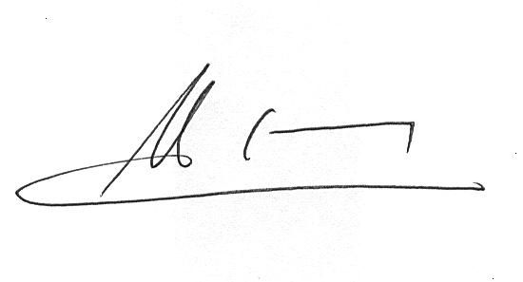

Jean-François Lepetit

